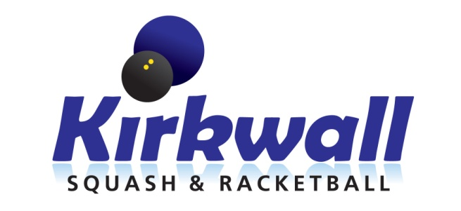
Kirkwall Squash & Racketball Club is holding the Orkney Open Squash Championship 2016/17 at the Pickaquoy Centre in Kirkwall on Saturday 11th and Sunday 12st February, 2017. We expect a full day of play on the Saturday with competitive matches ending around lunchtime on Sunday to allow visitors to catch return flights and ferries. There will be Plate competitions to ensure that everyone gets a few games. Depending on the number of entrants some local entrants may have to play on Friday evening, 10th Feb.
Entries for Women’s and Men’s events must made by 1st February by returning this completed form to mail@kirkwallsquashclub.co.uk or by post to Ian Stout, 24 Scapa Crescent, Kirkwall, Orkney, KW15 1RL. The entry fee of £10 should be paid before play commences. Payment can be made by cash, cheque or transfer to the Kirkwall Squash & Racketball Club account at the Royal Bank of Scotland, Sort Code 83-24-07, Account 00185369 quoting player name as reference.

Entry
Name
Address
Postcode
Telephone (mobile preferred)
Email
Gender |  | M/F
Could you play on Friday evening, 1st Feb, if necessary? Y/N

If you require further information please email mail@kirkwallsquashclub.co.uk or call or text 07511 749208. For more information on events and accommodation in Orkney go to www.visitorkney.com.
